Lab experiments
1. Create a new process by invoking the appropriate system call. Get the process identifier of the
currently running process and its respective parent using system calls and display the same
using a C program.

INPUT:
#include <stdio.h>
#include <unistd.h>
#include <sys/types.h>

int main() {
pid_t pid = fork();

if (pid == 0) {
printf("Child Process\n");
printf("PID: %d\n", getpid());
printf("Parent PID: %d\n", getppid());
} else {
printf("Parent Process\n");
printf("PID: %d\n", getpid());
}
return 0;
}

OUPUT:
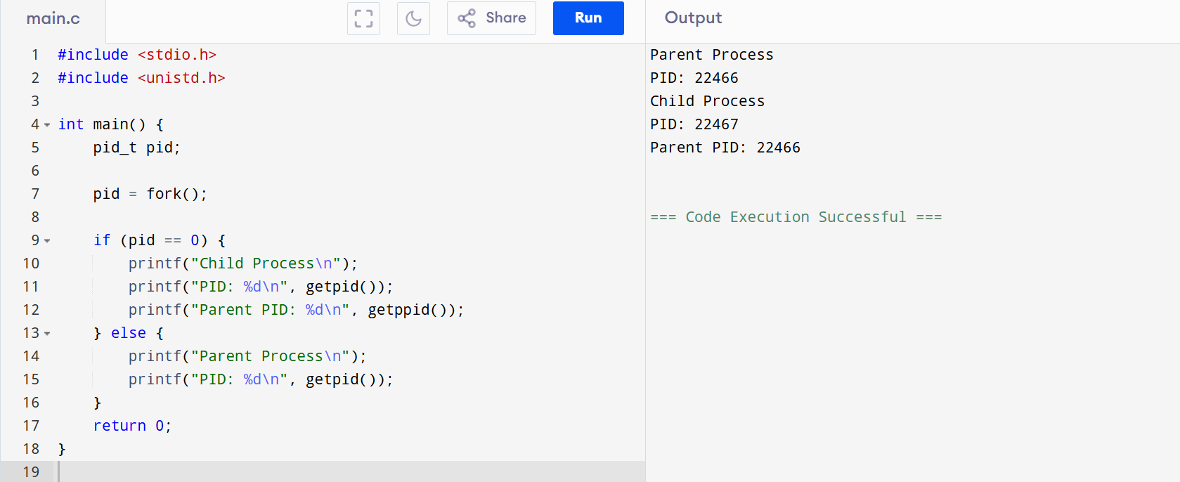

2. Identify the system calls to copy the content of one file to another and illustrate the same using
a C program.
INPUT:
#include <stdio.h>
#include <fcntl.h>
#include <unistd.h>

int main() {
int f1 = open("a.txt", O_RDONLY);
int f2 = open("b.txt", O_CREAT|O_WRONLY, 0644);
char buf[100];
int n;

while ((n = read(f1, buf, sizeof(buf))) > 0)
write(f2, buf, n);

close(f1);
close(f2);
return 0;
}
OUTPUT:
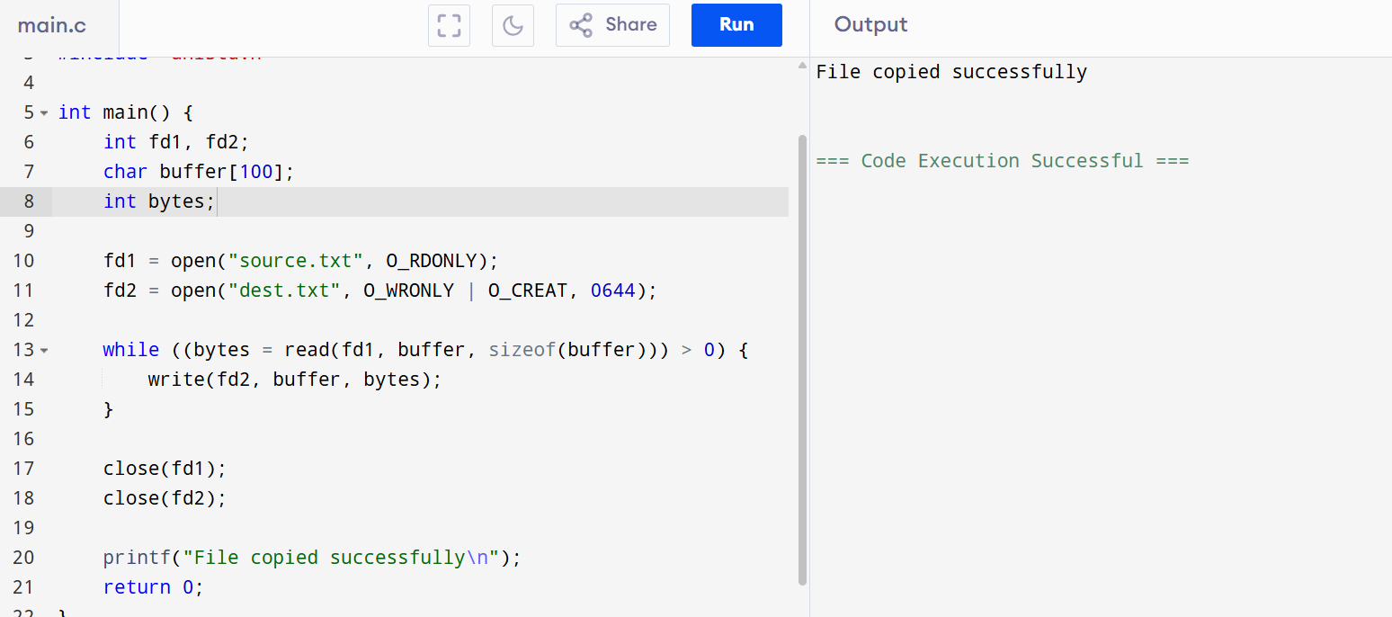

3. Design a CPU scheduling program with C using First Come First Served technique with the
following considerations.

a. All processes are activated at time 0.
b. Assume that no process waits on I/O devices.
INPUT:
#include <stdio.h>
int main() {
int n, bt[10], wt[10], tat[10];
scanf("%d",&n);
for(int i=0;i<n;i++) scanf("%d",&bt[i]);
wt[0]=0;
for(int i=1;i<n;i++) wt[i]=wt[i-1]+bt[i-1];
for(int i=0;i<n;i++) tat[i]=wt[i]+bt[i];
for(int i=0;i<n;i++)
printf("P%d WT=%d TAT=%d\n",i+1,wt[i],tat[i]);
return 0;
}
OUTPUT:
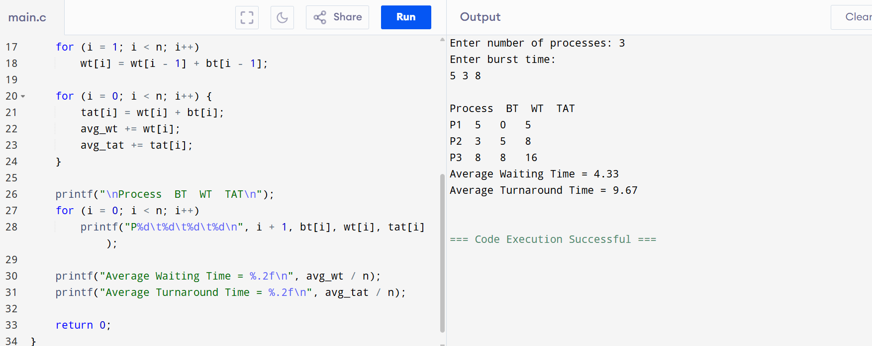

4. Construct a scheduling program with C that selects the waiting process with the smallest
execution time to execute next.
INPUT:
#include <stdio.h>
int main() {
int n, bt[10], wt[10], tat[10], t;
scanf("%d",&n);
for(int i=0;i<n;i++) scanf("%d",&bt[i]);
for(int i=0;i<n;i++)
for(int j=i+1;j<n;j++)
if(bt[i]>bt[j]){t=bt[i];bt[i]=bt[j];bt[j]=t;}
wt[0]=0;
for(int i=1;i<n;i++) wt[i]=wt[i-1]+bt[i-1];
for(int i=0;i<n;i++) tat[i]=wt[i]+bt[i];
for(int i=0;i<n;i++)
printf("P%d WT=%d TAT=%d\n",i+1,wt[i],tat[i]);
}
OUTPUT:
